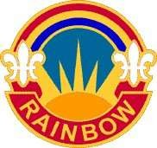

The RAINBOW Bugler

*Publication of the 42d Infantry “Rainbow” Division Association*

Vol. 39 15 January 2025

**Board of Directors**

**President Pat Alesia Vice President Frank Ombres Hudson Valley C/C Frank Degano**

**Downstate C/C William Vorlicek**

**Secretary Vacancy**

**Treasurer Frank Sasiadek**

**Alternate Ex. Comm. Members**

**Nominations**

**By-Laws Comm Thomas Principe Historians Paul Schottenhamel**

**Webmaster Donald Roberts Dwn. St. Chap., VP Steve Oleksak Dwn. St. Chap., Sec Hank Zalak**

**H. V. Chap., VP Vacancy**

**H. V. Chap., Sec Sal Mongiovi**

**H. V. Chap., Treas. Paul Gross**

**NEXT BOARD OF DIRECTORS MEETING AT KING UMBERTO’S, 1200 HOURS.**

**12 FEBRUARY 2025**

**TAPS**

**Jul ’24 to Jan ‘25 Roll**

**ROBERT SWIECIKI**

**JOSEPH CARMONA**

**JOHN LOCK**

**HUDSON VALLEY CHAPTER MEETING SCHEDULE**

**Location: FINO’s RESTAURANT**

**1 Baltic Place, Croton, NY**

**Lunch Cost: $30.00 per person**

**Wednesdays, 5 February 2025**

**7 May, 17 Sep, 10 Dec 2025**

**Meeting 1200 Hours**

**RSVP: Chapter Secretary**

Sal Mongiovi (914) 469-5310

1115 Frost Ln, Peekskill, NY 10566 [MongioviSalvatore@hotmail.com](mailto:MongioviSalvatore@hotmail.com)

### DOWNSTATE CHAPTER MEETING SCHEDULE

**Location: VETROS RESTAURANT**

**SOUTH OZONE PARK, NY**

**Wednesdays, 19 MAR, 11 JUNE, 17 SEP 2025**

**Cocktails: Noon– Meeting 1300 hrs**

**RSVP: Chapter Secretary**

**Hank Zalak** (917) 571-9471

61-35 75th Place, Middle Village, NY 11379 [Hzalal@aol.com](mailto:Hzalal@aol.com)

This NEWSLETTER is published two times a year on 15 Jan and 15 July respectively by the Secretary, 42d Infantry “RAINBOW” Association, c/o 155 Locust Street, Valley Stream, NY 11581

~~.~~**Individual Annual Dues: $25.00**.

The BUGLER does not carry paid advertisements. **Pg. # 1 of 11**

# President’s Message

As we enter the New Year, I wish our Rainbow 🌈 Family a Very Happy, Healthy, and Safe New Year!

We held our Annual West Point Golf Tournament on Monday 29 July and it was a great success. One hundred golfers participated and all had a fantastic time. As a result of their generosity and the generosity of our sponsors; our Association was able to donate $1000 to the RDVF Scholarship Program and $1000 to the Children’s Leukemia Research Association. Thanks to our Golf Committee: Frank Ombres, Frank Sasiadek, Sammy Mantilla, Barry Regalheim , Sal Mongiovi , Dominic Morelli and Andy Leider for helping to make our golf tournament a very successful one. Special thanks to Dominic and Andy for setting a new record in the sale of raffle tickets

Once again, thanks to Bill Volicek for planning and organizing our Veterans Day Ceremony at our 42d WWI Monument in Garden City. Col Lou DiLeo performed his beautiful rendition of the singing of our National Anthem; and played Tapes. The 11th New York Regiment provided the Color Guard and Firing Detail. Thanks to BG(R) James Whalen, Chaplain Mark Getman, and Bert Cunningham for their help and support. Special thanks to Kevin Connolly for playing the bagpipes during the ceremony.

In addition, thanks to Frank DeGano and Bob Mariani for participating in a Wreath Laying Ceremony at the McArthur Monument at West Point on Veterans Day. A Job well done!

Our Annual Association Holiday Luncheon was held on Saturday November 16th at Russo’s On the Bay in Howard Beach. Congrats to our Holiday Luncheon Committee for their outstanding efforts in planning and organizing for the event. Over 350 guests were in attendance to include: Korean, Vietnam, Iraqi Freedom Veterans and Gold Star Family Members. Members of the Nassau County and Suffolk County American Legion were also in attendance. In addition, several members of the Military Order of the Purple Heart, Chapter 21 were present for the festivities. Santa Claus(George DeSimone) and our Elf(Bobby Cochran) distributed toys and $100 Gift Cards to Korean War Veterans and Gold Star Family Members. Once again, we thank our Association Vice-President for his hard work and commitment in securing donations which provided us with the opportunity to invite our special guests and to present gifts to them. Frank Ombres thanked our donors and also presented plaques of appreciation to those donors present.

Our DJ provided delightful music and entertainment in the form of a great comedian and singers.

Special thanks to Sal Mongiovi for his willingness to overextend himself in publishing our Rainbow Bugler.

Looking forward to seeing all at Chapter Meetings!

Rainbow 🌈 Never Forget!

God Bless All and God Bless America

Pat Alesia

**Rainbow Board Meeting 16 Oct 2024**

2- Roll Call:

Association:

Pasquale Alesia, Pres

Frank Ombres, V/P

Frank Sasiadek, Tres

Downstate Chapter:

Bill Volicek, C/P

Hudson Valley Chapter: Excused

3- Acceptance of Minutes: A motion to approve the minutes of the last Board Meeting was made by Frank S. And seconded by Frank Ombres. Minutes were accepted by a vote of 3-0.

4- Treasures Report: An accounting of funds received and expenses from our Holiday Luncheon will be detailed at our next Board Meeting.

5- Presidents Report:

A- Our West Point Golf Outing was a tremendous success with 100 golfers participating.

B- Holiday Luncheon was discussed to ensure bus transportation was in place, seating arrangements finalized, DJ and entertainment, Color Guard, and bouquet distribution.

6- Next Board Meeting: Wednesday 12 Feb at Noon at King Umbertos .

7- Adjourment: Motion to adjourn made by Frank S. And seconded by Frank Ombres. Motion accepted 3-0. Meeting adjourned at 1330hrs.

# SAVE THE DATE:

# Our Annual Luncheon will be on 15 November 2025

Our Annual West Point Golf Outing will be held on 28 JULY 2025

**If you plan on joining us on Monday, 28 July 2025 you will need to get your PAID reservations in as soon as possible after you receive this year's FLYER. Looking forward to seeing all on the 28th of July.**

### VETERAN’S PRAYER

**Dear Lord, I’ve served my Country, My love for her is strong.**

**I’ve stood behind “Old Glory”... When others thought her wrong.**

**I’ve joined in celebration And raised a toast in cheer. I’ve pledged her allegiance and sung her anthem dear.**

**I’ve wept for fallen comrades Who proudly fought and died,**

**The freedoms they defended. I cherish deep inside.**

**I’m proud to be an American For her strength and peace I pray.**

**There is no greater country...**

## God Bless the USA!

Downstate Chapter Chairperson Corner

﻿Seasons Greetings to all. Best wishes for a happy and healthy New Year.  
As we begin our 37th year, I think it’s important to review what we have accomplished as an Association.  
We now conduct 2 Wreath Laying Ceremonies each year at the Division Monument in Garden City New York. What started out as a lone member, COL Bob Anderson, presenting a wreath, has morphed into a great ceremony that each time grows in size. Wish Bob was here to see what he started.  
The Annual Golf Outing has also become a tradition that continues to grow. Thanks to all we are able to donate to the Rainbow Division Veterans Foundation (RDVF) for their scholarship program. For the first time ever, 3 Association families received scholarships. My granddaughter Abigail, Joe DelDuca’s granddaughter Jordan, and Bill Solmo’s son Joseph. Congratulations to all and good luck with your college career.  
However the greatest accomplishment in my mind has been the Annual Luncheon. What started out with very small affairs has developed into very well attended events. The last event had over 360 attendees. I was very proud of the support from the Downstate Chapter members. We had an increase in attendance plus we had a large number of members who donated for a Veteran to attend. Thanks to George, Bob and Veronica for going above and beyond the call of duty. Looking forward to this year’s Luncheon. Mark your calendars, November 15, 2025. Same place, same time but more importantly same PRICE.  
Our next meeting will be in March and it will be a luncheon at Vetro’s in Howard Beach.  
Once again, thank you for your support.  
RAINBOW  
Bill Vorlicek

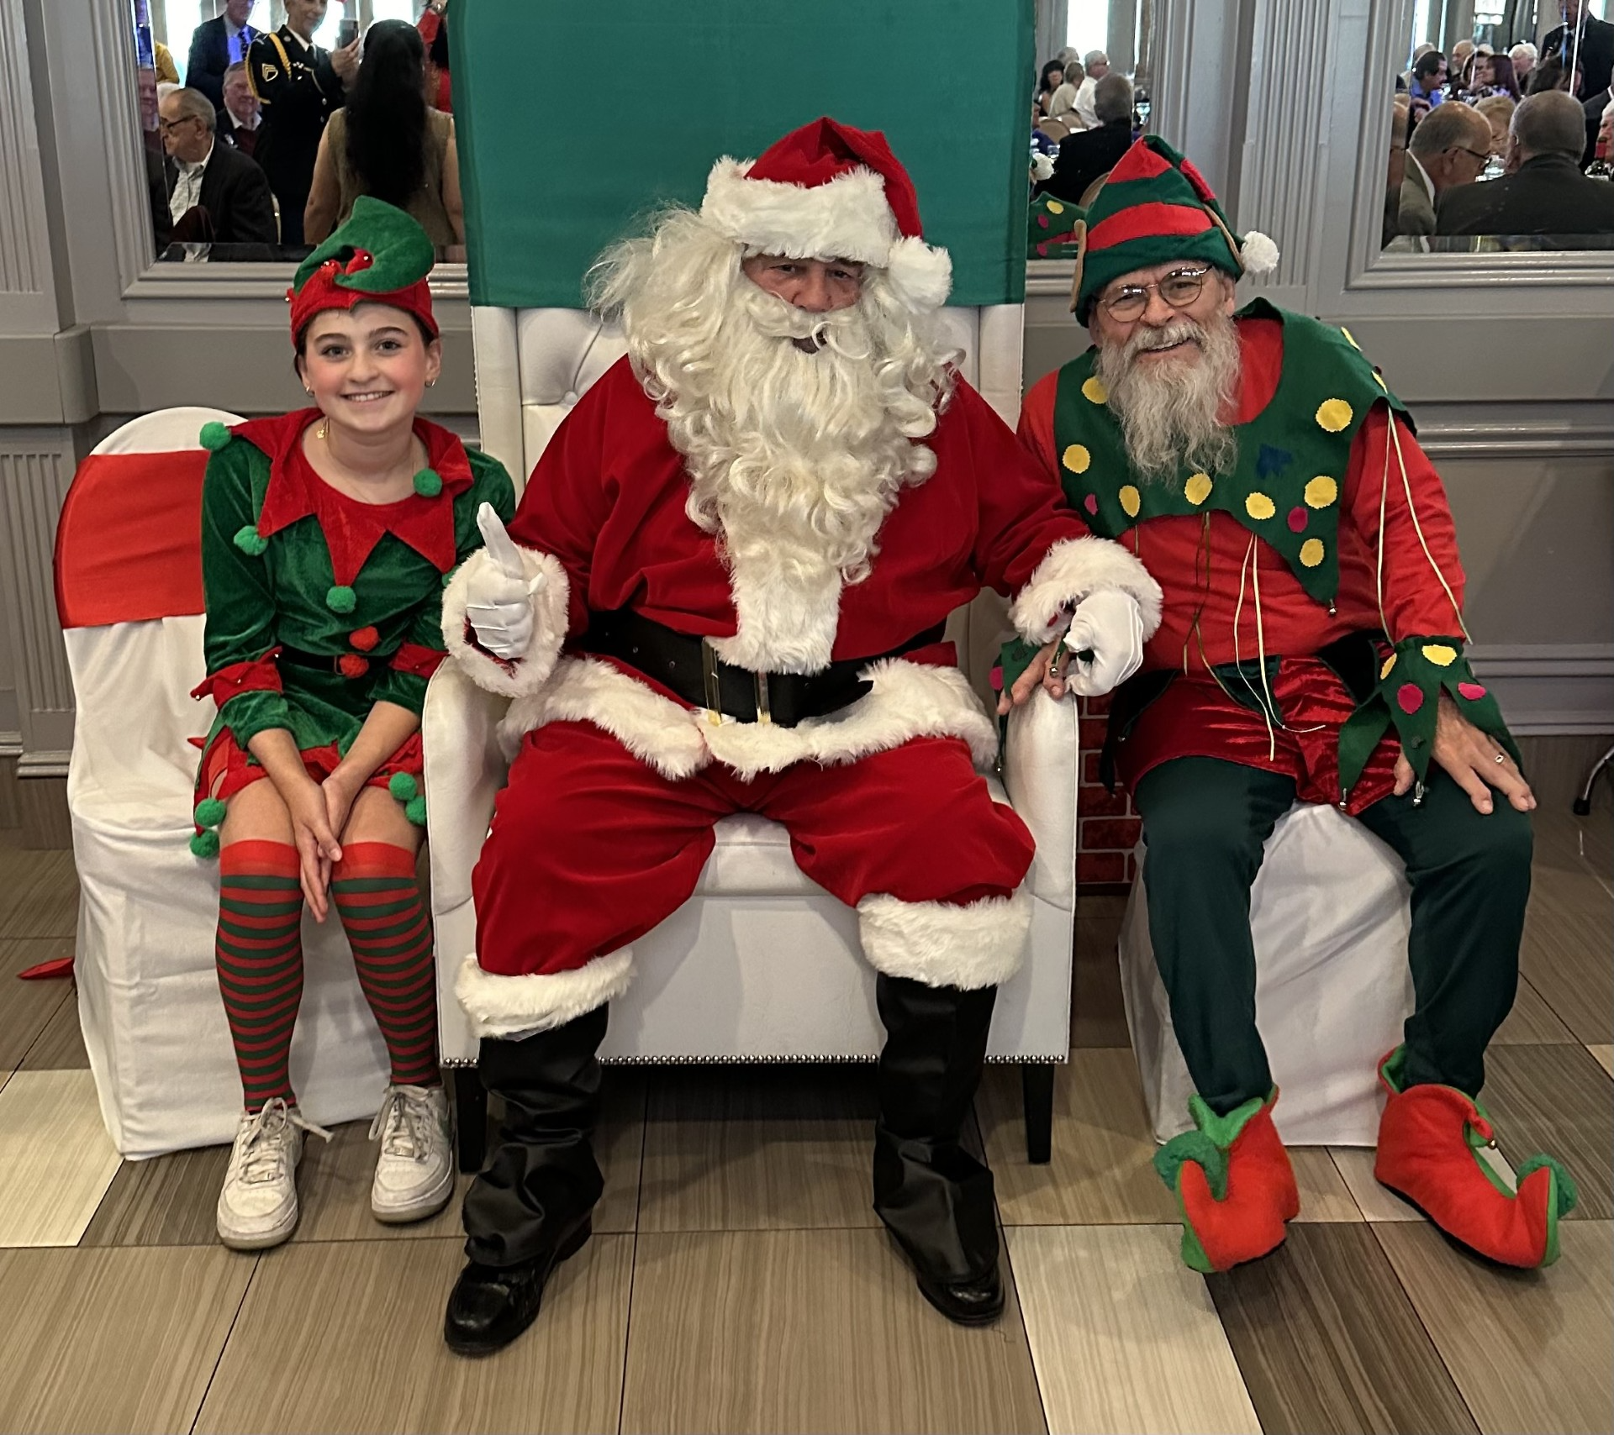

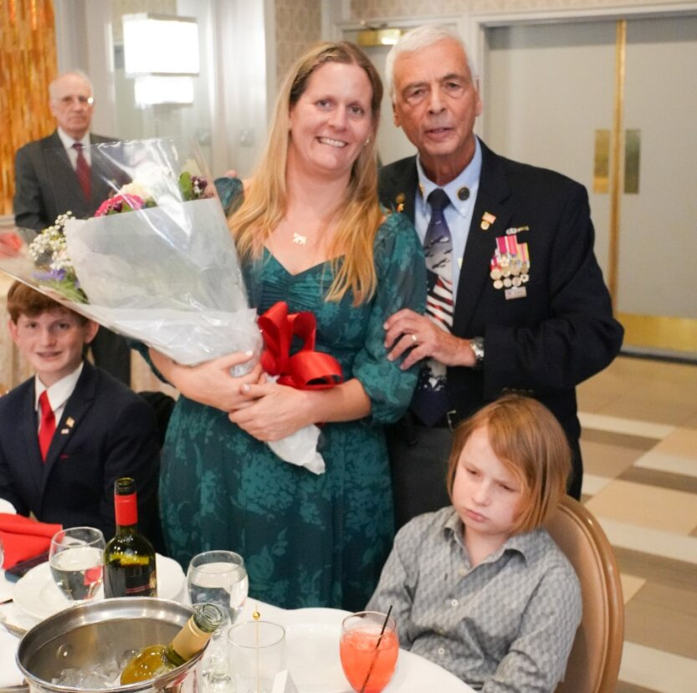

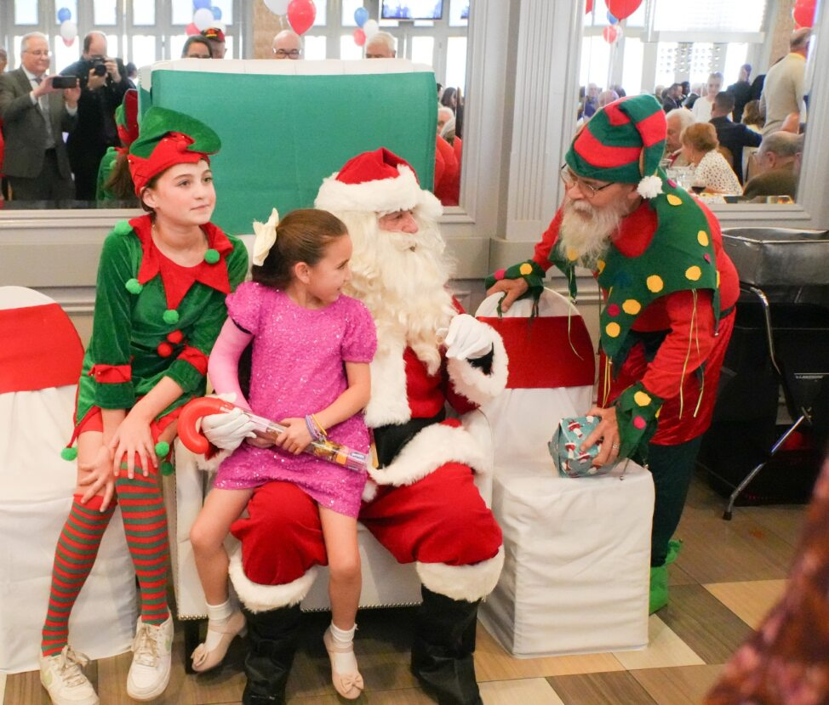

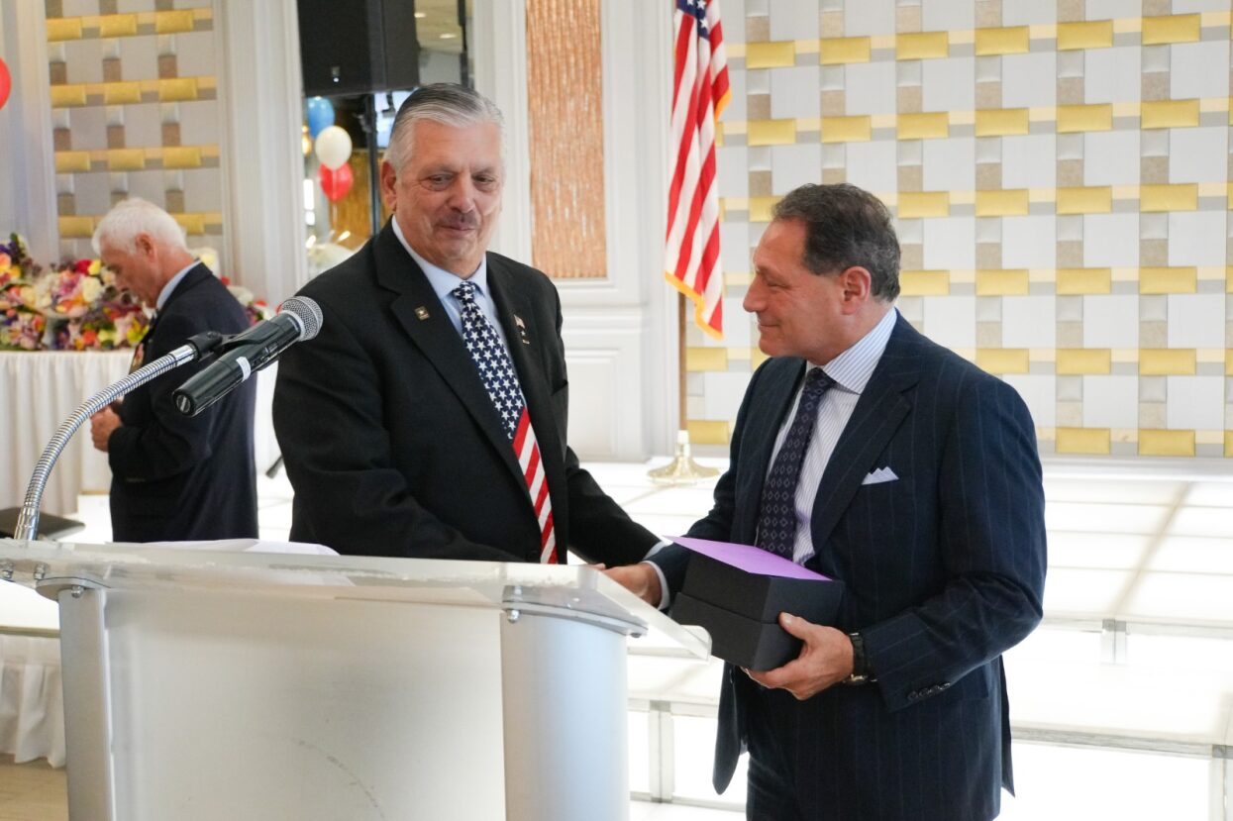

HUDSON VALLEY CHAPTER CHAIRMANS MESSAGE

Happy New year everyone. 2024 had its many challenges for all of us. I hope that 2025 will bring some welcome relief. More changes are coming as of this writing.  We have lost several members this year and they will be announced at our February meeting . Speaking of our next meeting , all annual members should be prepared to pay their dues at the meeting. I will be asking for a quest speaker to give us some info about the changes to Camp Smith.

Please try to make our meeting February 5 at Fino's Restaurant

Frank Degano

